
Overcome the strain of life’s stresses and increase your resilience and joy!


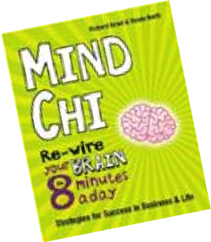

Sign up now!
Vanda North – The ONLY Resilient Woman Warrior,
author and creator of Mind Chi.
For more information please see www.MindChi.com or email me at vanda@mindchi.com or call me on 01202 798 638
SPECIAL OFFER:
Book a 1/2 day Mind Chi Resilience Session (held 23rd February) for £40.00, and receive a FREE, signed copy of ‘Mind Chi’! Offer ends 15th February 2013
Become a MORE Resilient Women
We conduct individual, public, group or corporate sessions, which may vary from a 20 minute introduction to an in-depth
2-day Mind Chi training.
Session may include:
- your own SOS stress-bustin’ kit - ready for stressful emergencies
- daily resilience and bounce for whatever life throws at you
- feeling the reins of control in your hands - even in the midst of chaos
- knowing how to improve your memory and concentration
- a signed copy of ‘Mind Chi’ worth £14.99!
Guaranteed — a delightful and thoroughly worthwhile event — a simple 8 minute
a day routine which will replace any stress with resilience and joy!
What others say:
“Mind Chi has improved my perception of how good my life really is”
“Mind Chi has improved my performance at work and allowed me to develop better relationships.”

